**CS-250 Final Project: Sprint Review & Retrospective**

I believe the description of one of the most common Agile approaches as Scrum is very fitting, it can be rough and tumble with everyone lining up week after week similar to play after play. The various roles played by each member of the team is important to the overall success of the development project. Starting with the Product Owner (Christy) who acts as a liaison between the development team and the client (Amanda). Product owner’s add value by creating the vision of the end goal or product by talking to Amanda and gathering information necessary to progress the project.

The Product Owner documents this information as user stories so that everyone is on the same page and helps clarify anything that is not understood by the team. Primarily a good Product Owner should ask a lot of questions to the Client understanding what is needed to add value for the client. Christy could’ve used a few different formats of questions but stuck to the most common, the 5 Why’s which aides in identifying the value, direction, and who benefits the most. Within the SNHU Travel project the Christy used questions effectively to identify the best product that had the most value, specifically by hosting a meeting with possible customers to the SNHU Travel website. These specifications made it easier for the tester to understand what tests were necessary and the goals of the website.

The tester works hand in hand with both the developer and the product owner. It’s their job to understand the user stories and create tests around what features will be present in the final product. The tester for the SNHU Travel project had to create their own scenarios to test for within the user stories. After the initial scenarios were created, the tester had to send an email for further specifics on the fine details of the user stories and how they should operate. Transparency, understanding, and trust are important qualities to have in the relationship between the tester and the product owner since they rely on honest information flowing to an from one another. The developer has to understand how the website should feel to end-users and what features are add the most value to Amanda based on Christy’s direction.

Developers are somewhere in between the product owner and tester, they do the actual work on developing programs and applications that fit into the vision of the product owner. The developer’s end application should also be able to pass all of the tests that the tester has created. Within the SNHU Travel project the developer had to create working code in Java using jar’s and zipped folders to understand what the general feel of the application should look like. The framework provided to them made it easy for a developer to create the final code to be submitted to the client. Their job can be difficult to complete and hit expected deadlines but with a good product owner and scrum master each sprint should be able to be completed with time to spare for testing purposes.

The Scrum Master is a mentor and facilitator of sprints for the development team. Scrum Masters provide a crucial role to help the developer understand what they are working on and to coach them on anything they may not have worked with in the past. Day to day activities for the Scrum Master are more about getting people together and onto the same page. Scrum Masters focus as mediators between members of the development team, they naturally act as the glue to the team keeping the team working together.

The user stories came to completion because the information being made for them was the most up to date at the time of creation or review. The SNHU Travel project had a general framework of getting a website together for vacation packages. As the project progressed forwards more information was described to the team and made the user stories more accurate and valuable to Amanda. The Scrum-Agile approach allowed the team to change and did not have the project fall apart when a change was made to it.

The Scrum-agile approach kept the project on track to succeed because it was flexible enough to bend but not break the team. The original documentation from the Christy said that the main focus would be on vacation packages which felt more luxurious in design. The end-users (the customers of SNHU Travel) seemed to be wealthier individuals that were taking long relaxing vacations with plenty of activity to do. But, after a report from Amanda came through the product owner had to change the vision to a detox and wellness website. The customer base for the website changed drastically and focused on descriptions of what activities the customers could do while getting away from the stresses of life and to work on their own inner growth. Some sensitivities were discussed within the project to make sure that customers did not feel attacked while seeking help through SNHU Travel. This discussion lead to some changes within the website and added value back to the product as a whole.

Below is a sample of my communication with the team about switching from Waterfall to Agile.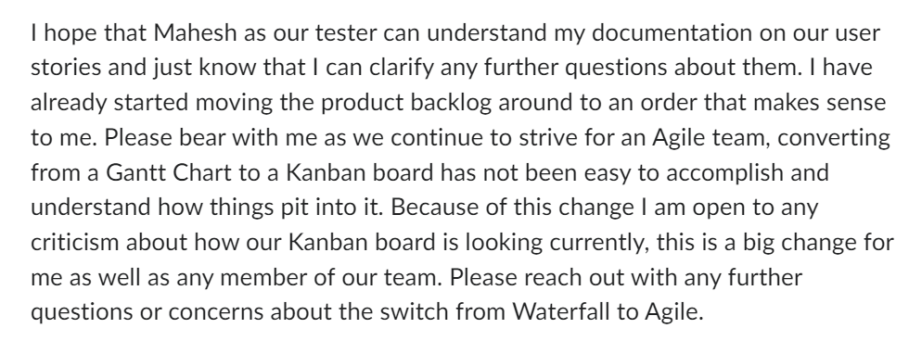

As the product owner it was my responsibility to take ownership for the User Stories and to work closely with the tester of the project. I also tried to keep open and honest communication discussing my inexperience with Agile and allowing for feedback from the team to provide better communication as the project progressed. I was also trying to ease some tensions and establish trust within the development line by saying “this is a big change for me as well as any member of our team. Please reach out with any further questions or concerns about the switch from Waterfall to Agile”.

The Scrum-agile principles that helped the team the most were transparency, respect for people, and just-in-time production. The team worked at a steady pace throughout the project and did not overwork themselves. The information provided in chunks made it easy for the SNHU Travel development team to understand the MOSCoW requirements of the project. As more information was learned the team could easily change direction without being committed to one specific goal or timeline. Instead the project had a rough deadline that allowed some levity which I believe reduced the tensions in the team. The transparency and respect for people made it easy for the team to effectively communicate amongst themselves. The lack of information control on the product owner/project manager’s part made one less responsibility for Christy to worry about.

I think that the effectiveness of the SNHU Travel project was directly impacted by the usage of the Scrum-agile approach. For me the biggest pro was the flexibility of Agile, I don’t think that the Waterfall methodology would have been able to change the project around to accommodate detox and wellness centers as the focal point of the project. The biggest con on the other hand was the constant communication. Communication is great and is vital to any development team. The amount of communication and commitment to the team made it hard to complete tasks because it is a constant burden on the team. Having a stand-up meeting is great, but I think that the stand-up meetings time goal should be 3 minutes plus one minute per each member of the team. Having a hard-set no longer than 15 minutes just means that the team will likely spend time just filling that 15 minute gap up in the day instead of working on something more productive. I think that the Scrum-Agile approach for the project was the best choice for the SNHU Travel project. The value provided to Amanda is not measurable but it’s clear to see is more than if Waterfall had been chosen as the method for the development process.